TRAINING AND PLACEMENT CELL
ACADEMIC YEAR 2024-2025
AASAANS FDP on 26.02.2025 and 27.02.2025
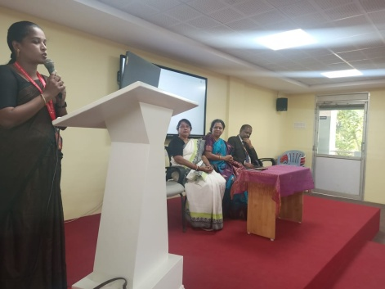
The Training and Placement Cell of Achariya Arts and Science College, Puducherry, organized a Faculty Development Program in association with AASAANS, Puducherry, on the 26th and 27th of February 2025. The program was conducted in both the forenoon and afternoon sessions at the ACET Seminar Hall, from 9:00 a.m. to 4:00 p.m. on both days. A total of 10 faculty members participated in the program. The session focused on enhancing the skills, knowledge, and teaching methodologies of the faculty members. It included interactive discussions, presentations, and practical training delivered by experts from AASAANS. The initiative aimed to promote continuous professional development and ensure that the faculty stay updated with the latest trends in education and technology. The event was successfully organized and coordinated by the Training and Placement Cell of Achariya Arts and Science College, reflecting its commitment to academic growth and institutional development.

